Connecting a User to SSO Provider
Follow these steps to link a buyer account to your SSO provider:
- Log in to your environment as an Admin User.
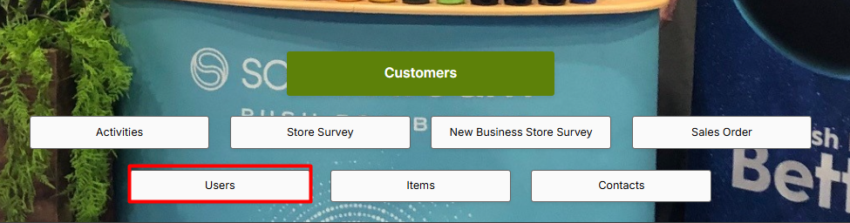
- Navigate to Users → You'll see the list of users.
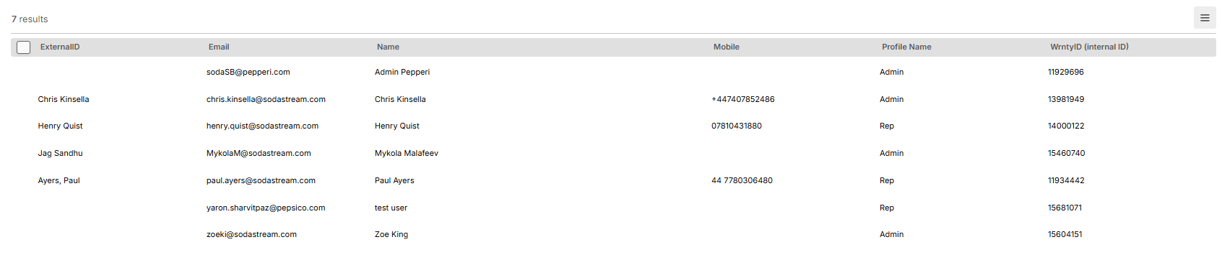
- Select the user you need to connect to SSO.
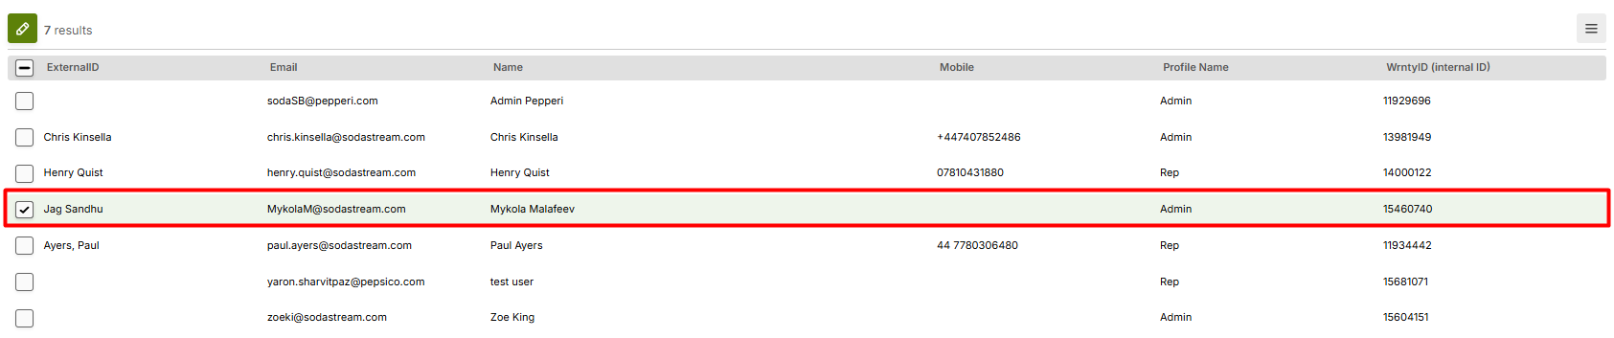
- Click Edit (pencil icon).
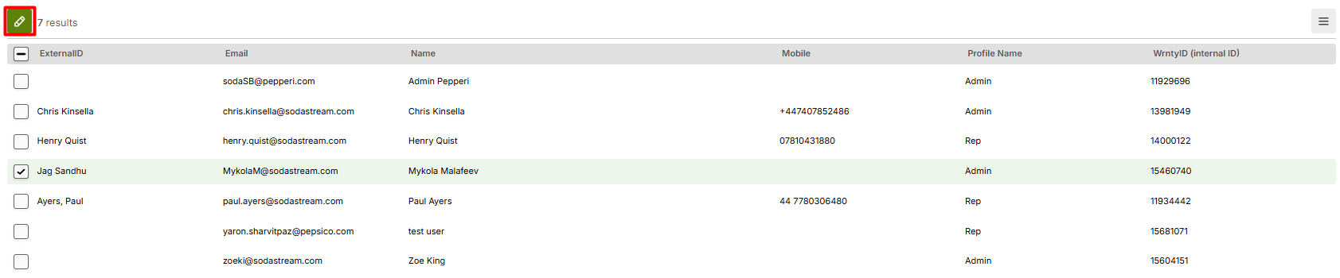
- From the dropdown menu, select "Change Security Group".
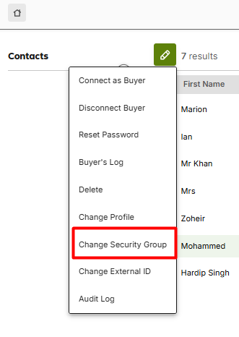
  - A modal window will appear.
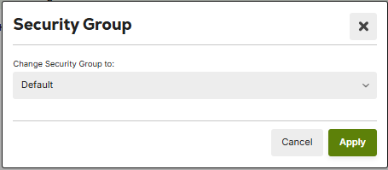

- In the dropdown, choose your SSO provider's name.
- Click Apply to save the changes.
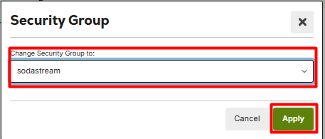
✅ Done! The user will now be authorized via the SSO provider.

Connecting a Buyer to SSO Provider
Follow these steps to link a buyer account to your SSO provider:
- Log in to your environment as an Admin User.
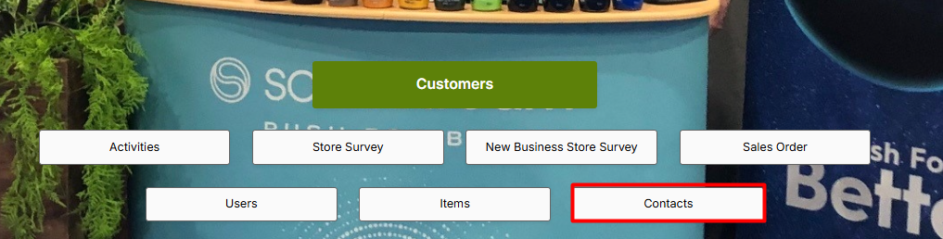
- Navigate to Contacts → You'll see the list of buyers.
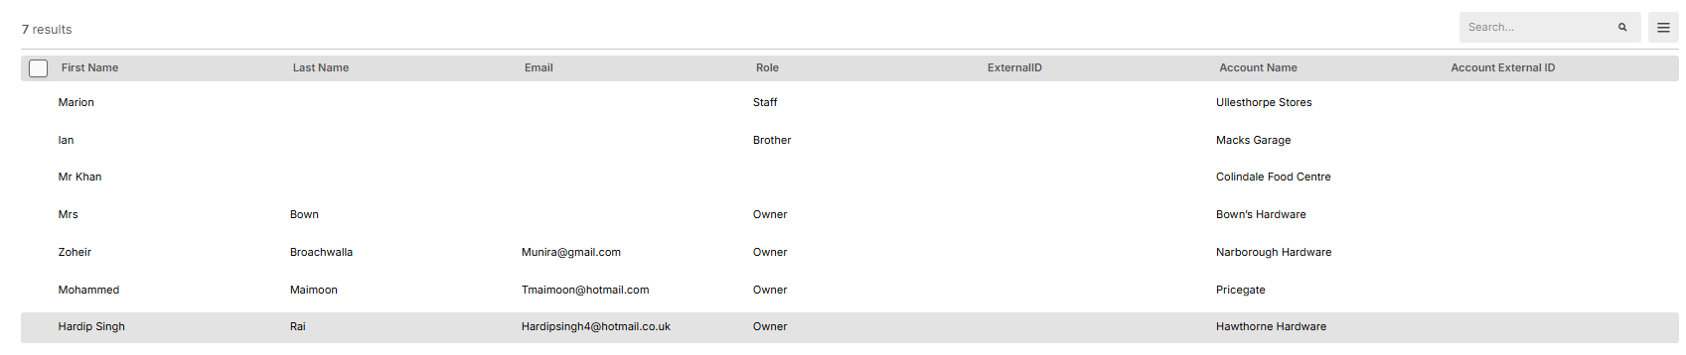
- Select the buyer you need to connect to SSO.
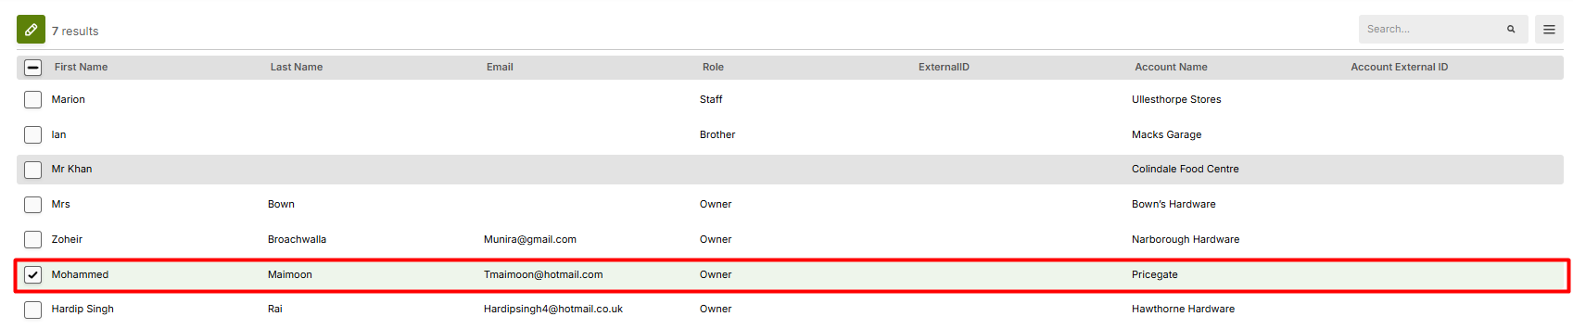
- Click Edit (pencil icon).
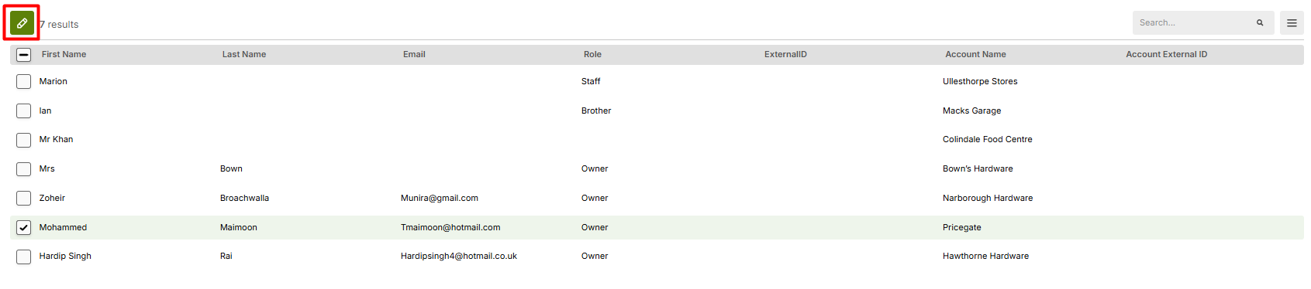
- From the dropdown menu, select "Change Security Group".

  - A modal window will appear.


- In the dropdown, choose your SSO provider's name.
- Click Apply to save the changes.

✅ Done! The buyer will now be authorized via the SSO provider.

